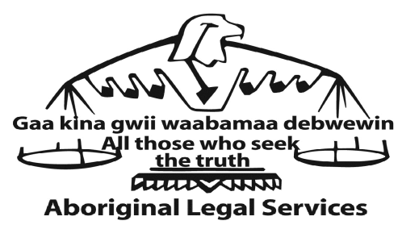
Suite 500 - 211 Yonge Street, Toronto ON M5B 1M4 (T) 416.408.4041 or 416.408.3967 (T) (Toll-Free) 1-844-633-2886 (F) 416.408.1568 (E) alst@web.ca www.aboriginallegal.ca

FOR IMMEDIATE RELEASE
Monday, November 27, 2017

Family Reacts to Charges Withdrawn Against OPP Officer Mark McKillop

LONDON, ON: This morning Jason A. Nicol, the Crown Attorney responsible for prosecuting Constable Nicholas Doering with the London Police Service and Constable Mark McKillop with the Ontario Provincial Police in the death of Debra Chrisjohn, withdrew all charges against Constable McKillop. The charges against Constable Doering will proceed.

Earlier this year in July, both officers were charged with criminal neglience causing death and failure to provide the necessaries of life after the 39 year old mother from the Oneida Nation of the Thames near London, ON died less than three hours after being arrested on September 7, 2016. She had been brought to the attention of the police for obstructing traffic and was arrested by Constable Doering before being transferred to Constable McKillop on an outstanding warrant related to a shoplifting charge.

Brittany and Ruby Chrisjohn, sisters of Debra, are angry that Constable McKillop will no longer be required to answer for his actions in the criminal justice system. The decision by the Crown “… is hard for the family to understand,” says Brittany, frustrated. “We hope that everyone who played a role will be held accountable.”

If the withdrawal of the charges is “… what it takes for justice to prevail, then so be it. Debra was my best friend and a beautiful person. Her life ended far too soon,” notes Ruby, sadly.

“Without knowing the specific details surrounding the death of Debra, it is difficult for the family to assess the decision by the Office of the Crown Attorney,” explains Caitlyn Kasper, lawyer at Aboriginal Legal Services and counsel for the family. “However, we know that as this active prosecution moves towards preliminary inquiry or trial, more details will emerge.”

“In the meantime, I certainly expect that the Ontario Provincial Police will be thoroughly reviewing the actions of Constable McKillop to determine if there were breaches of the Police Services Act.”

Contact: Caitlyn Kasper, Lawyer - Aboriginal Legal Services
Counsel for the Chrisjohn family
Phone: (416) 408-4041 ext. 229
Email: kasperc@lao.on.ca

